

GUI Design for e-SMP
Version: 04

Revision History
Date | Version | Description | Author
19/01/2012 | 01a | Create new from EMP_GUI_Design_Part 1_Concept 3.0.ppt | ITeal
26/03/2012 | 02a | Add new solution for request  Update International labels: add User + Level | ITeal
27/03/2012 | 02b | Add new Part for "Export CSV" | ITeal
28/03/2012 | 02b | Add Culture after Name for Main Label in Fiche Screen  Mass Update of Comment | ITeal
13/04/2012 | 02c | Add Common Part For DataBase Design | ITeal
25/05/2012 | 02d | Add Part 4, 5, 6:  - Import  - Export  - Online Help | ITeal
07/06/2012 | 02e | Updated and answer to CIRC's remark | ITeal
14/07/2012 | 02f | Update following Skype discussion on 14/06:  Control: Replace Grid in "Control Screen" by a log file to improve performance | ITeal
14/07/2012 | 03 | Add some precissions on interface | Iteal
22/10/2012 | 04 | Add message for Business control | Iteal

Table of Contents
Revision History 2
Table of Contents 3
List of Figures 5
1 PROJECT DOCUMENT 7
1.1 SPECIFICATION 7
1.2 OTHER REFERENCE 7
1.3 Glossary 7
2 Design Concept 9
2.1 Login Screen 9
2.2 EMP Layout 10
2.2.1 Header Area 11
2.2.2 Menu Bar 12
2.2.3 Navigation Bar 13
2.2.4 Working Area 14
2.3 Design Principle (Working Area) 15
2.3.1 List Screen 15
2.3.2 Delete 24
2.3.3 Fiche Screen 25
2.3.4 Mass Translation Dialog 27
2.3.5 International Labels 28
2.3.6 Traceability 29
2.3.7 Request 31
2.3.8 Export CSV 35
2.3.9 Import 35
2.4 Database Design Principle 36
3 Control 38
3.1 Total / Partial Control 38
3.2 Unit Control 40
3.3 Rules for Control 41
3.3.1 Control of Translation 41
3.3.2 Control of Business Rule 41
4 Import 51
4.1 Total Import 51
4.2 Table Import 53
4.3 Unit Import 56
4.3.1 Common Case 56
4.3.2 Unit Import for Food Links / Recipe Links 58
4.3.3 Unit Import for FoodList / Recipe List 59
4.4 CSV Import 61
4.4.1 Example of csv import 62
4.4.2 FoodList 63
4.4.3 BrandName 63
5 Export 64
5.1 Create Epicsoft Database 65
5.2 Export IM Database for Decentralized Mode 67
5.3 Import IM Parameter 69
6 Online Help 70
6.1 Structure the help 70
6.2 Administration 71
6.3 Accessing the help 72
7 Annex 74

List of Figures
Figure 1 Login Screen 9
Figure 2 EMP Layout 10
Figure 3 Global view of EMP interface 11
Figure 4 Header Area 11
Figure 5 Menu Bar 12
Figure 6 Navigation Bar 13
Figure 7 Working Area 14
Figure 8 List Screen 16
Figure 9 Buttons on Action Bar 17
Figure 10 Comment on Data 18
Figure 11 Send email 19
Figure 12 Select source to do the table import from 19
Figure 13 Unit Import Screen 20
Figure 14 Export csv – select file name 21
See 3.2 21
Figure 15 International Labels 22
Figure 16 Display Traceability Information in List Screen 23
Figure 17 Tooltip example 23
Figure 18 Mass Status & Comment 24
Figure 19 Fiche Screen 26
Figure 20 Sample of fiche screen 27
Figure 21 Mass Translation Dialog 28
Figure 22 International Labels With Trace and without trace 29
Figure 23 Search Bar with Traceability Information 29
Figure 24 Search Bar when Traceability Information is collapsed 29
Figure 25 Traceability Information 30
Figure 26 Traceability for data with Action = Delete 30
Figure 27 Show Change dialog 31
Figure 28 List screen with email button (Request) 32
Figure 29 Email Dialog to send request 33
Figure 30 Select Type of Request 34
Figure 31 Database design for MS 36
Figure 32 Control MS Database menu 38
Figure 33 Control Screens at library 38
Figure 34 Control Screen at project 39
Figure 35 Control screen at Country 39
Figure 36 Unit Control 40
Figure 37 Control Result example 41
Figure 38 Import From Parent Project 51
Figure 39 Select data to be Import 52
Figure 40 Action Bar with "Table Import" button. 53
Figure 41 Select Perimeter to import from 53
Figure 42 Unit Import Button in red border 56
Figure 43 Import Data 57
Figure 44 Imported Data 57
Figure 45 Unit Import for Food Maximum 58
Figure 46 Select maximun to import for selected food 59
Figure 47 Unit Import for food list 60
Figure 48 Select Food to Import 60
Figure 49 Import FoodList – Summary 61
Figure 50 Import csv 62
Figure 51 Select csv file to be import 62
Figure 52 Log of csv Import 63
Figure 53 Export Epicsoft Database 64
Figure 54 Version Management Screen 64
Figure 55 Epicsoft Database - Export Process 67
Figure 56 Export SC database 68
Figure 57 Display process of Export SC database 69
Figure 58 Help button on action bar 72
Figure 59 Dialog to display all help files 73

- PROJECT DOCUMENT
- SPECIFICATION
No | Document | Description
1 | EMP-SFG-02a | SFG for EMP
2
- OTHER REFERENCE
No | Deliverables | Description
1
2
3
4
5
6
- Glossary
Abbreviation | Description | Note
Itv | Interview
MSApp | Maintenance & Setting Application
SCApp | Security & Communication Application
IMApp | Interview Manager Application
HMI | Human Machine Interface

- Design Concept
- Login Screen
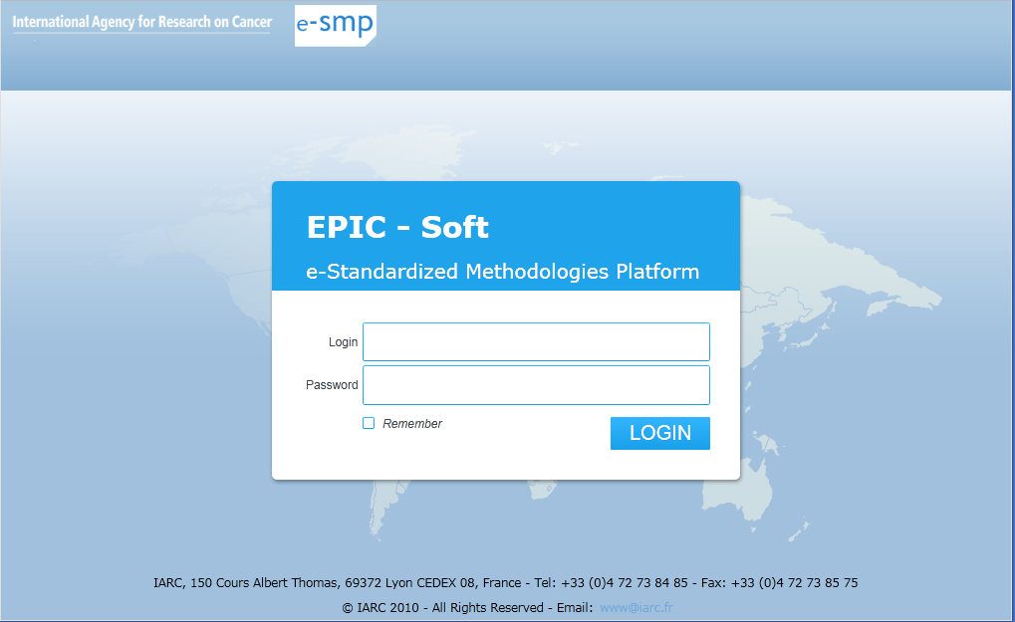
- Login Screen
This screen is displayed first when user navigates to e-SMP, it will have the following features:
- Users enter their Login & Password and click on Login
- Users are able to remember their credential for next usage (The Login screen will not being displayed if the credential is remembered)
- The Login & Password will be stored in Isolated Storage of Browser (Use Base64 to encode)
- Password in database will be encoded with base64 (different key than Isolated Storage)
- Without Login & Password, User cannot go further on e-SMP
- Implement the forgot password: Ask for email address and send email to user to re-initialize the password
- EMP Layout
- EMP Layout
There’re 4 main areas:
- Header
- Menu Bar
- Navigation Bar
- Working Area
The global view of EMP Layout will be:
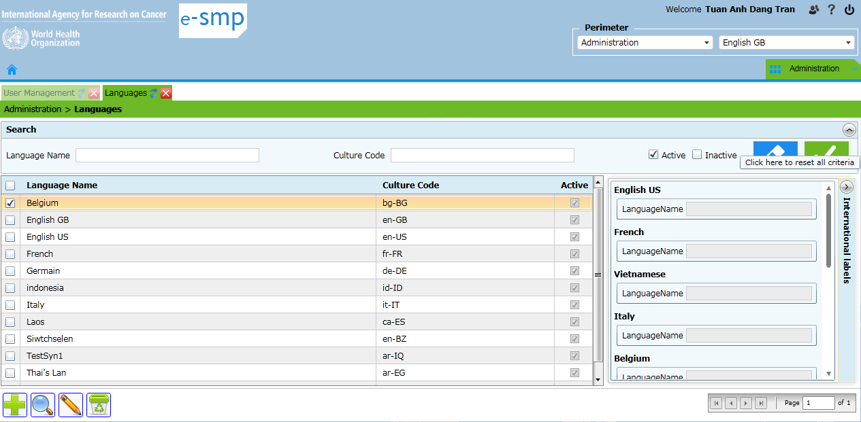
- Global view of EMP interface
- Header Area
- Header Area
Notes:
- Combo Perimeter (Project – Country) includes: Administration, Library, Project or Project / Country
- Combo Language: Is for the language of data in the Perimeter.
- Interface language is defined in User Profile
- Make the Header as small as possible.
- Add the possibility to collapse the header
- Use Icons for help, profile, logout
- Menu Bar
- Menu Bar
- There’re 4 items in menu bar:
- Home Button: Use to go to Home Screen
- Maintenance & Setting Menu
- Interview Manager Menu
- Administration Menu
- Rule
- The 3 menus & their content will be displayed or not depending on the perimeter & privileges of user (e.g. if user doesn’t have any permission on IM the IM menu will not be displayed).
- Home Button will be used to go to home screen.
- There’ll be 2 static Perimeters: Administration & Library (see the rule in the comment)
- Perimeter and menus (always dependant of the user’s rights). Perimeters are :
- Administration:
  - Only Administration menu is visible.
- Library:
  - Only Maintenance & Settings/Library menu is visible.
- Project:
  - Maintenance & Settings/Project is visible
  - Maintenance & Settings/Library is visible to consult the Library in visualization only. This menu’s elements are differentiated visually.
  - Maintenance & Settings/country menu is visible but inactive.
- Project/Country
  - Interview Manager is visible
  - Maintenance & Settings/Country is visible
  - Maintenance & Settings/Library and Maintenance & Settings/Project are visible to consult in visualization only. These menus’ elements are differentiated visually.
In all cases the application guides the user regarding which screens(s) he can access and be active in through the “green lights” system, the business rules and the user-rights.
- Each main menu (MSapp, IMapp and Administration) and its corresponding open tabs are to be differentiated by color (example colors, to be defined). The active tab is of the same color as its category, inactive tabs are faded.
- In addition to the menu there is a home screen accessible by the icon. It should offer similar access as the corresponding menu(s) in a more friendly way taking advantage of the full page space available.
- Gwh: the Home screen needs more details about its content and organisation.
[ITeal]: to be completed
- Navigation Bar
- Navigation Bar
- e-SMP supports opening multiple screens at the same time, each screen will be open in 1 tab (as in excel where you can have different sheets). For example, we can imagine one tab with the food list, one with the fdfacet…
- Navigation bar is 1 tab control which includes multiple tab items, each tab item represent 1 opened screen.
- Navigation bar holds the header of all tab items. Each header include:
- Title: Short Name of Opened screen
- Icon: Icon that represent for the screen
- Refresh button: use to refresh the corresponding screen
- Close button: use to close the screen
- The tab background color will correspond to the application it belongs to. The color will be faded if the tab is not the currently selected one.
- User can switch between screens by clicking on the tab header
- In order to have better performance, there’re will have a limitation of maximum number of tabs that open at the same time (Maximum =6). When the limitation reached :
- Close the oldest tab or
- Display the error message
- Working Area
- Working Area
- There’ll have a Breadcrumbs in the top of working area to indicate the "Current opened screen"
- Users do their business in the different screens displayed in Working Area. The screen will be opened by:
- Click on the Menu
- Click on the button in Home Screen
- Open from another screen
- There’re 2 types of screen:
- List Screen: screen with the function to search and display a list of objects (in a grid) such as: User List, Language list… JPM: A list screen is a list screen without possible action (e.g. display always the same list). Each list screen will be display as a tab in Navigation Bar.
- Addition or modification of items will use the fiche screen.
- Deletion can be performed directly in the list screen
- Fiche screen: Is the screen that contains the detail information of each object. Each object will be opened on a modal dialog by double click on the item of list screen (or click on view / edit button in the action bar at bottom after selection in the list). The following screens will be considered as Fiche Screens:
  - User Detail
  - Function Detail
  - Project Detail
  - ….
- Design Principle (Working Area)
- Multiple screens are opened at the same time: User can switch between screens by clicking on Tab Header (Navigation Bar).
- Navigation: The flow of navigation in all screens in e-SMP will be:
- From left to right
- From top to bottom
- Optimized Resolution: The Interface will be best fit with the resolution of 1400x 900
- Use graphic buttons: add, delete, modify, validate, cancel…
- User Pager for list screens to optimize the performance:
- Client: Can implement for all
- Server : Should implement for screens with large data only such as : Interviews, notes, food, recipes
- Search Screen: Filter Area is at top, grid to display result is at bottom
- Search Panel: Collapsible / Expandable
- Grid:
- Foldable: right click on column header to choose the column (s) that displays on the grid
- Sortable: by click on column header
- Double click on row to open fiche screen
- List Screen
The most common screen in e-SMP is the Search Screen with Filter Area at the top and 1 Grid to display search result at the bottom. The screen includes:
- Search Bar (Collapsible / Expandable) :
- Criteria
- Search Button (Graphic Button): Click to Search and display result
- Reset Button (Graphic Button): To reset all Criteria
- Grid: to display result
- “Select Column” (=first column in the left of the grid): Use to select row (s) in grid (multi selections is possible)
- Info Column (2nd column): Contain 2 icons which indicate the "Trace Status" and the presence of "Trace Comment".
- Desc Column (last column): Contain 1 icon which indicates the presence of "Description".
- Data Column: To display Data
- Column Header: User can click on header of each column to sort data in grid by the current column
- Double click on each row will open the Fiche screen in a modal dialog; user can view & update the record. Close the modal dialog will return to List Screen
- Action Bar: Actions displayed on Action Bar based on the selected items in the list and based on the business of each screen (you can see an example by seeing the Gmail), such as:
- Collaborative
- Control
- Mass Translation
- Add
- Delete
- View
- Edit
- Import (Table or Unit)
- Restore (for archived items)
- Export (if has)
- Report (if any)
- ….
- List Screen
- Buttons on Action Bar
- The following table explains all the possible icons in action bar:
No | Action | Icon | Description
1 | Add |  | Create new Item
2 | View |  | View Detail of selected item
3 | Edit  Mass Update |  | Open fiche to edit the selected item.  For some screens, when users select multiple items this action will be used to open the « Mass Update » dialog.
4 | Status & Comment |  | Click to open the dialog to change status & comment of all selected item(s) in grid
5 | Alert |  | Click to open the dialog to send alert for all selected item (s) in the grid
6 | Mass Translate |  | Click this button to open dialog to do the mass translation
7 | Export CSV |  | Click to export all selected items to csv file
8 | Delete |  | Click to delete all selected item (s). The deletion will follow the collaboration rule
9 | Control |  | Click to do the control for data of the current screen
10 | Online Help |  | Click to show the dialog that displays all help files of current Perimeter
11 | Select |  | Click to select data from Library to Project or from Project to country (for photo screen)
12 | Total Import |  | Click to do the total import
13 | Unit Import |  | Click to do the Unit import
14 | Import Csv |  | Click to do the import csv (Food List – BrandName)
15 | FUF |  | Click to open the FUF screen (foodlist only)
16 | Add Shadow |  | Click to add shadow for a food (foodlist only)
- Possible actions in MS
- Gwh: For each button of the toolbar please show the interface of the popup/screen:
- Comment
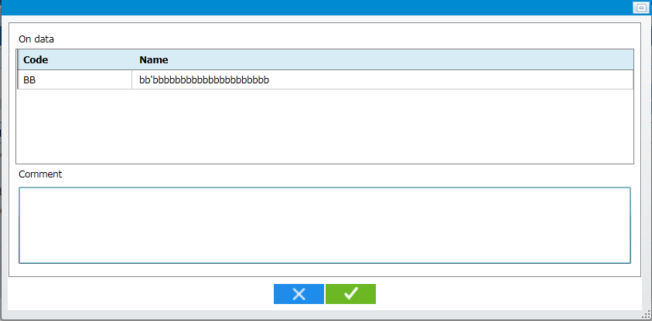
- Comment on Data
- Alert
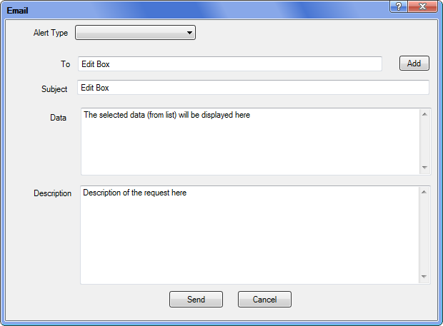
- Send email
- Table Import
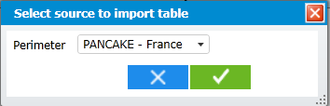
- Select source to do the table import from
- Unit Import
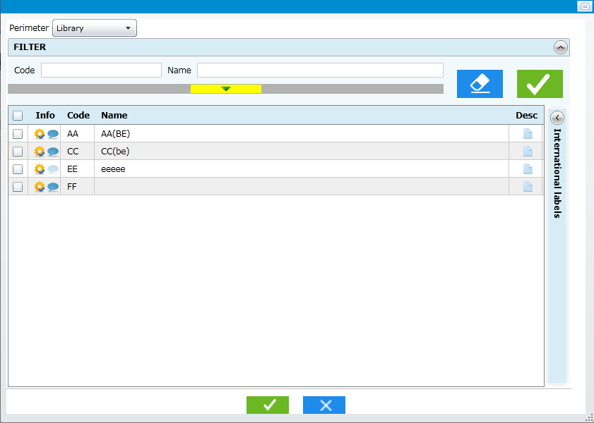
- Unit Import Screen
- Export (csv)
Open the save file dialog to input csv name --> click OK to export to this file
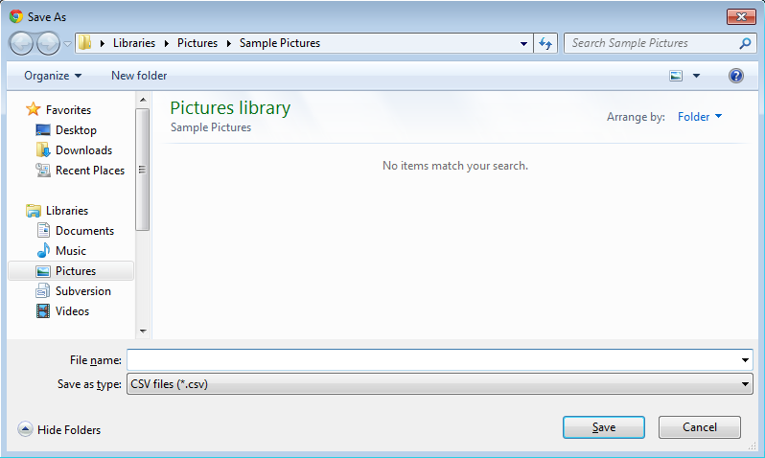
- Export csv – select file name
- Control
See 3.2
- Online help
See 6
- International Labels
- International Labels
The International Labels:
- Will be integrated in 1 Panel called “Item Details” which is able to collapse / expand
- Will be changed following the selected item in the grid.
- Traceability Information
Traceability Information will be attached to List screen as following:
- Status will be displayed as “Text Color” of each row
- Other information: use tooltip when user point the mouse on each row
- Display Traceability Information in List Screen

Tooltip will include the following data: Status, description and Comment
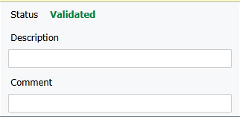
- Tooltip example
- Mass Update of Status
Users can update the status & comment in mass by selecting multiple items on grid and click on the button "status & comment" in action bar:
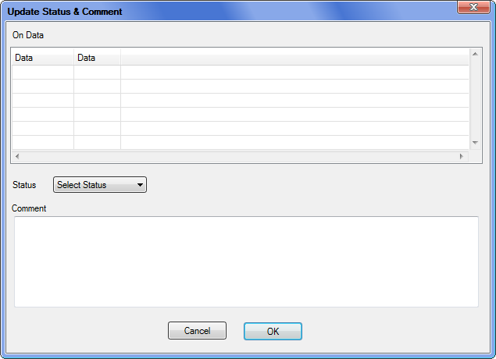
- Mass Status & Comment
The status that is available in the Combo Status will be based on the user right:
- User without modification right: nothing & disabled
- User who can modify + without validation Right:
- In Process
- To be Approved
- To be Reviewed
- User who can modify + with validation Right:
- In Process
- To be Approved
- To be Reviewed

The status & comment will be updated to all selected record
- Delete
The deletion of 1 record will depend on the following:
- Constraint with other data (in used)
- Its Trace
- User right (with validation right or not)

The following types of deletion are possible:
- No Action: For record with State = "Archived"
- Archived:
- For Exported Record: With State = In Used.
- For Library record which has been imported to Project / Country
- For record with state= New
- If user has validation right: delete physically if record isn't in used by other (such as Group is used by Food), display error message in other case
- If user hasn't validation right:
- If record has been validated or record with Level higher than current user --> Update to "In Process" + Action = "Delete"
- Otherwise --> delete like the case with validation right

Note: We have the cases of cascade deletion --> they're not considered at data in used.
- Fiche Screen
- Fiche screen will be used to manage the detail information of objects such as: User information, Project information…
- Fiche screen can be opened by:
- Click to “View” or “Edit” (on action bar) of each object in activity screen (Fiche Mode)
- Double click on each row
- The Fiche screen will be opened on a Modal Dialog; user can close this tab at any time.
- The International Labels and Traceability information will be attached in fiche screen and user can edit and save them.
- Wether the fiche is opened in visualization or edition depends on the rights of the user.
Note: Traceability is available only for MS
- Fiche Screen
Note: In Fiche screen, the culture will be displayed before the main label as in example:
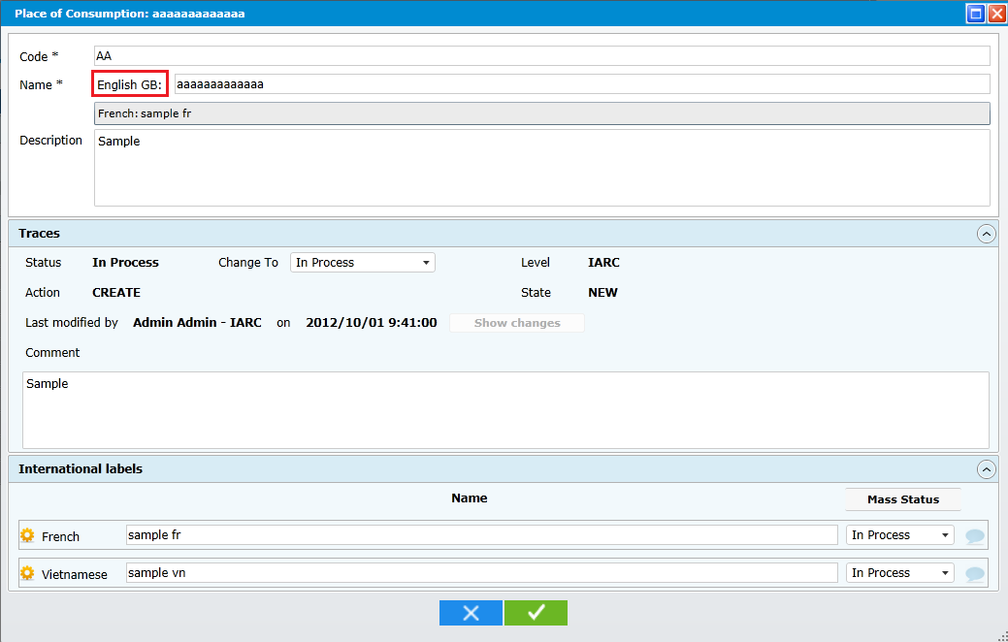
- Sample of fiche screen
- Mass Translation Dialog
Mass Translation Dialog will be displayed when user clicks on the “Mass Translation” button in each screen. Example of screen including the translation traceability variables:
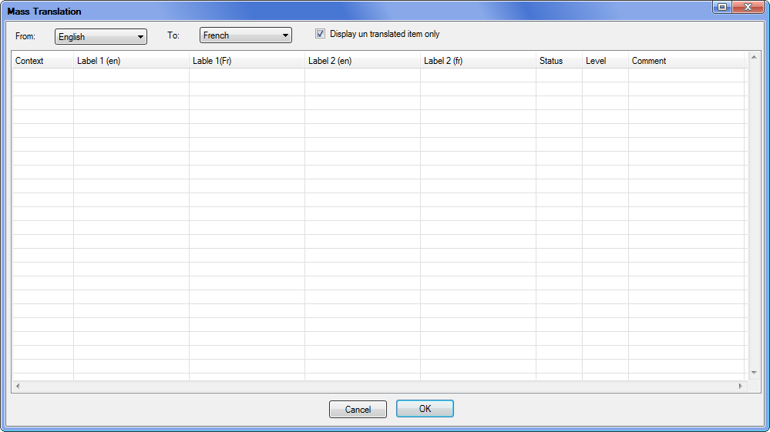
- Mass Translation Dialog
Note:
- Add a combo "From Language"
- Need to add more contexts for the translation of each screen. The translation is done for all tables with different database constraints, so there'll have 2 cases:
- Common Translation Dialog: Use for almost screen with a typical context (such as Name & Code)
- Concrete Dialog: Use for special case, when a screen needs more context than the typical one.
- User can click on header to sort
- There's only 1 filter: "Display un-translated item(s) only
- International Labels
- The International Labels are:
- Attached to each row of the grid
- Available on each “Object Details” Fiche Screen
- The Record & Translation Traceability information is only available for MSapp
- The Save & Edit of International Labels go with the Save & Edit of Data. Click Save & Edit data to Save & Edit of International Labels (1)
- On each Translation: Click on “…” button to open the comments associated and user is able to add more comment
- The International labels will be read-only in list screen and editable in fiche screen
- There're 2 types of international labels:
- With Trace: Maintenance & Setting
- Without Trace: Security and Communication, Interview Manager
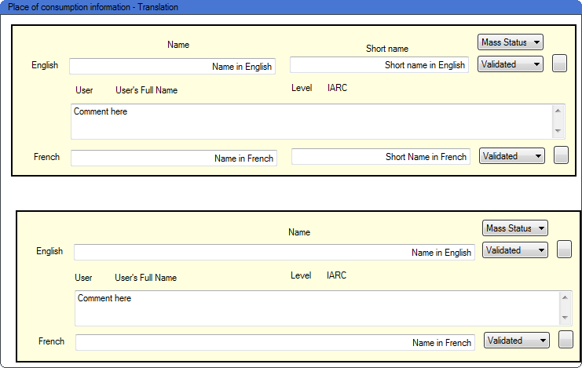
- International Labels With Trace and without trace
- Traceability
- Search
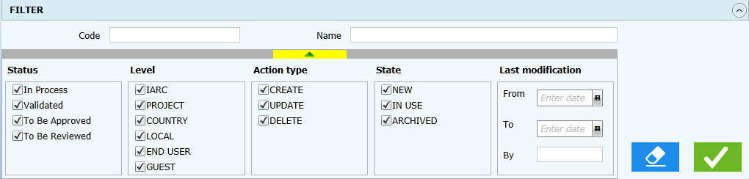
- Search Bar with Traceability Information
- Search Bar when Traceability Information is collapsed
Note:
- The Filter on Trace will be expandable / collapsible (click on arrow button at the bottom of Trace Area)
- Data displayed in the list will be colored according to the Traceability Information (See SFG)
- View / Edit
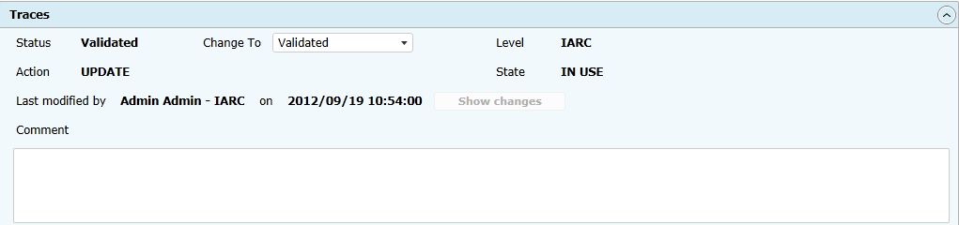
- Traceability Information
- State, Level and Action are automatically managed and are not modifiable by the user.
- The Traceability will be available for data in MS App only. It'll be available on the Fiche Screen.
- The Traceability information is only available on MS App only
- The Save & Edit of Trace Information go with the Save & Edit of Data.
- Click on Show Change to display the comparison between current data and last validated data. ShowChanges button will be enable only if this item isn’t in "Validated" Status and it has been validated before.
- In the case of Action = Delete: User can change the action = "Delete" or "Update"
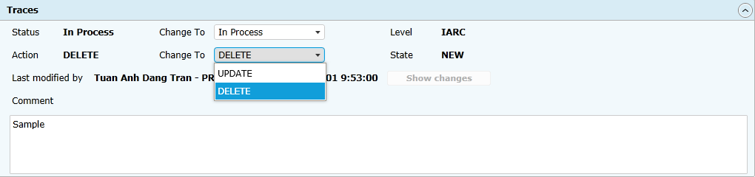
- Traceability for data with Action = Delete
- ShowChange & Revert
Click on Show Changes button in fiche screen to open the ShowChange Dialog:
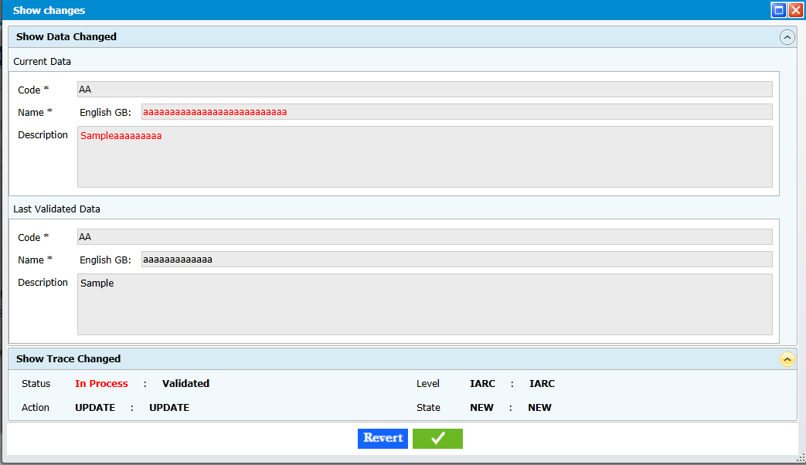
- Show Change dialog
Click on Revert button to revert to the last validated value. The translation will not be impacted by this revert.
- Request
Request to create: a user with the necessary rights will be able to add a record (this action is identified as “Request to Create”). This type of record should clearly identify with a specific color. Traceability information permits this identification.

There is no duplication of the record even in case of direct modification or delete. An archive of the old values is kept so it can be restored but the one and only record present in the system is the current one in its current status, potentially unusable elsewhere until it becomes Validated again.

The mean of modification/delete (direct or request) is function of its State (New/In Use) or by specification a Validated Record. To illustrate this point consider that a Food Validated/New could only be modified by lower levels through request but a Coefficient Validated/In Use could be modified by lower levels directly as the impact on the whole system is less.

Direct Add/Modify/Delete when allowed will be managed through the validation process in place as defined in the chapter “8.2 Collaborative Work” of the SFG.

[ITeal]: As discussed in Skype:
There'll have no request to add, we just need to give someone permission to add data in Library, Project. It's an normal action that can configure via function of SC.

Request to Modify or Delete: In the list screen --> Click on Email Button

Detail on request through email:
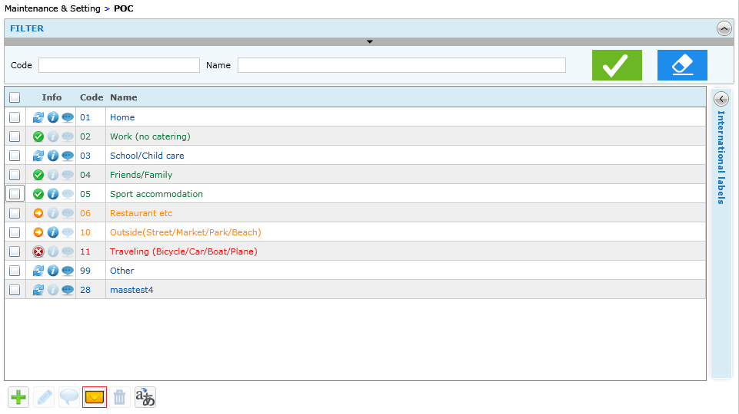
- List screen with email button (Request)

In the popup dialog, User can choose one of the following types:
- Normal Alert
- Request to Add
- Request to Delete
- Request to Modify
- Other (if needed)

- Email Dialog to send request

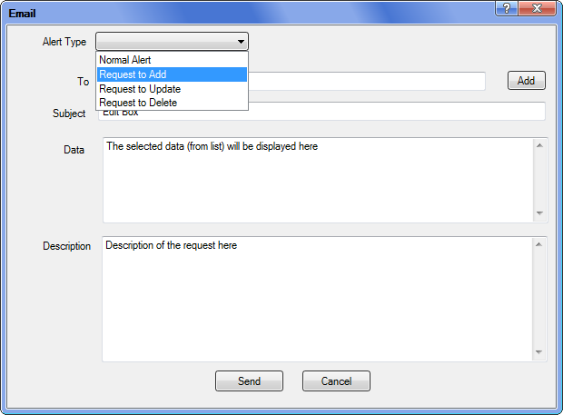
- Select Type of Request
User can select one of the Alert Types:
For each type, the system will control on different rule such as:
- For Normal Alert
  - All users will be possible to selected (Click on add)
  - User have to input the subject & Content
- For the Request to Add / Modify / Delete:
  - Request in Library, the users that will be available to select are: Users with IARC role in "Library", and we must select at least one user.
  - Request in Project, the users that will be available to select are: Users with Project Coordinator, IARC role in "Project", and we must select at least one user.
  - Subject: Auto Fill by the system such as --> "Request to modify for POC"
  - Content: Free text by user

- if user click on send, an email will be send to recipients with the content as above and the system will add a link to the content of this email --> User can click on it to open the e-SMP in the screen that made request (if he have enough privilege)

Note: the Content of email = Data + Description

- Export CSV
In each screen, we might have function to export to csv file; the rules for export are as following:
- if no selection: Export all according to current filter criteria
- if has selection: Export the selected items
- All data will be exported excepts:
- IdProject, IdCountry
- TraceComment, Translation Comment
- Last Validated Value
- Some control fields defined for management (IdSource, Import Type)
- Format of data (culture) is the same with the data displayed in screen
- Example of fields to be exported in FCO screen:
- Code
- Name
- Short Name
- Mode
- Principle
- Status
- State
- Level
- Action
- Last Modified
- Login
- User Info
- Description
- Name (Fr)
- Short Name (Fr)
- Status
- Level
- UserName
- Name (Vn)
- Short Name (Vn)
- Status
- Level
- UserName
- ....(For all available languages)
- Import
With the Unit Import / Table Import from Project:
- The record must be validated
- 1 record cannot be imported multiple times
- If the record is selected from Library and it's archived at the time of importation --> System will display a warning: process for single record, multi records.
- Database Design Principle
This is the database design for POC screen but it contains the common information that will be applied for all screens in MS:
- Database design for MS
In this design: There're often 2 tables for each screen:
- 1 Table for data + all traces + some fields for controlling of the application
- 1 Table for Translation (might not have)
- Depending business of each screen, more table will be needed but the main table with trace data is the same with POC
MS_POC
STATIC AREA | Id | int | Auto Increment, Primary Key, Unique Key, Not Null
 | IdProject | int | Foreign Key to Project Table  Not Null
 | IdCountry | int | Foreign Key to Country Table  Nullable  (For some screens, this field might not be used, it always be null) --> we need to keep it for Framework
 | Trace_Status | int | Status for Data
 | Trace_State | int | State for Data
 | Trace_Action | int | Action for Data
 | Trace_Level | int | Level for Data
 | Trace_Login | int | UserLogin
 | Trace_UserInfo | int | User Name + Level
 | Trace_TimeStamp | DateTime | The last update time (Server time)
 | Trace_LastValue | nvarchar(MAX) | Store last validated value
 | Trace_Comment | nvarchar(MAX) | Trace Comment
 | IdSource | int | Managed Field --> used for import
 | ImportType | int | Managed Field --> used for import
 | Description | nvarchar(MAX) | Fixed Comment
SPECIFIC AREA | POC_CODE | nvarchar(2) | Business field, the definition of this will depend on each screen (1 or more)
MS_POC_L10N
STATIC AREA | Id | int | Same Id with Data Table, foreign key to data table (delete cascade)
 | IdLanguage | int | Foreign Key to Language Table
 | IdProject | int | Same & Dupplicate with DataTable, but we need it to:  - Do the Partition & Index by Project – Country: Improve performance when data is large  - Do the Mass Translation (in this case, access only translation table will have better performance)
 | IdCountry | int
 | Trace_Status | int | Status for translation
 | Trace_Level | int | Level for translation
 | Trace_UserName | nvarchar(100) | User Name
 | Trace_Comment | nvarchar(MAX) | Coment of Trace
SPECIFIC AREA | POC_NAME |  | Business field, the definition of this will depend on each screen (1 or more)
- Control
- Total / Partial Control
In MS Menu / Tools, Click on "Control MS Database"
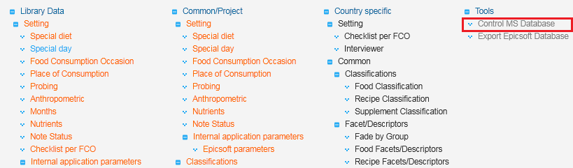
- Control MS Database menu
The following screen will be displayed allowing user to select the area to do the control and displayed the result:
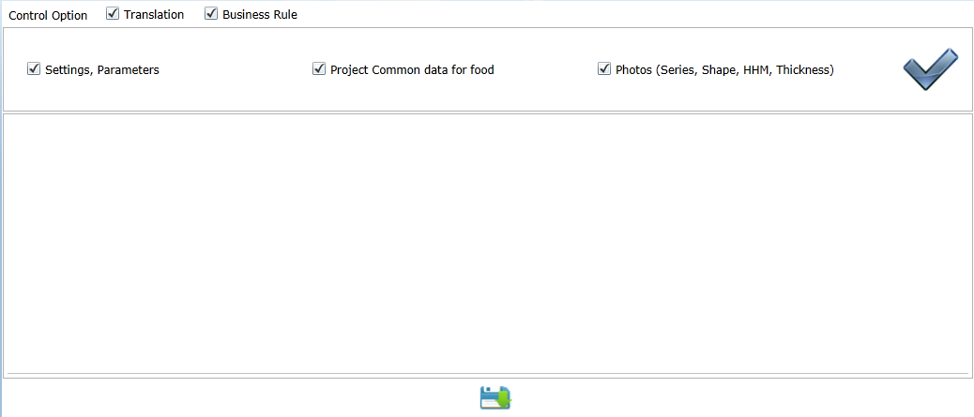
- Control Screens at library
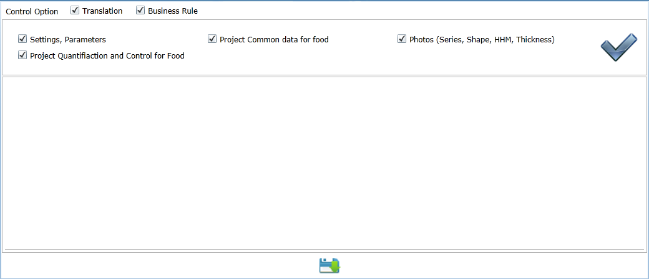
- Control Screen at project
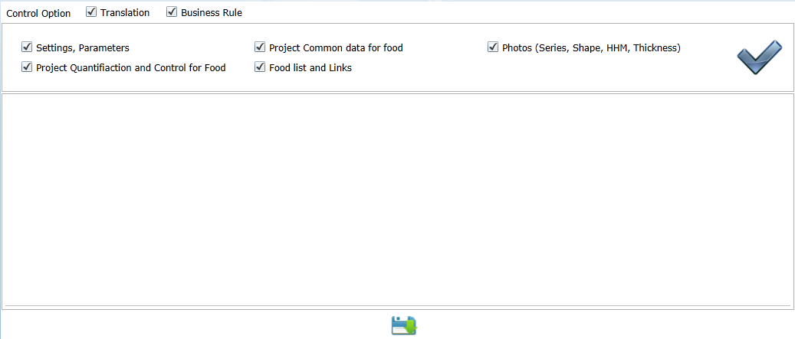
- Control screen at Country
The Items in Control Option are corresponding to items in Menu that will be loaded based on the selected Perimeter. Such as: In Library --> we have:
- Settings
- Classification (Food & Recipe)
- Descriptions (Food & Recipe)
- Photo Methods.
After click on "Start Control" button, system will do the control and display result in the bottom of screen.

The Rules to do the control are defined in 3.3
- Unit Control
In each screen, user can do the control by click on Control button in Action Bar.
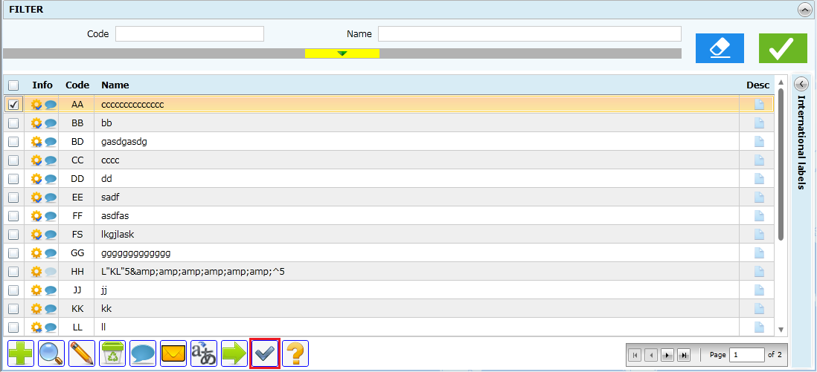
- Unit Control
The Rules to do the control are defined in 3.3. And the result will be displayed in a popup dialog.
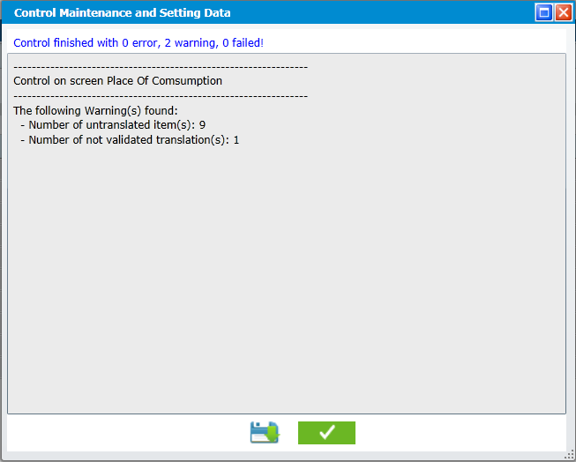
- Control Result example
- Rules for Control
- Control of Translation
This control will check the translation for the current perimeter for all items and displayed the Error as:
- Number of Items without translation / Total Items. For example: 10 / 100
- Number of translated item not validated / Total Items. For example: 15 / 100
- Control of Business Rule
All business Rule has been defined in checklists. Most of them have been satisfied by Database Design and Management of Fiche Screen. Only a few of them will need to do the control at exported time. This part will describe the specific rule that need to check with control:
- Settings
- Country
None
- Center
None
- Days
None
- Months
None
- Food Consumption Occasion
None
- Checklist FCO
Rule Id | Name | Type | Description | Message
CHK_FCO_001 | Reference Data | Error | FCO used by validated checklist has to be validated | FCO(s) used by validated checklist has to be validated. FCO(s) code: {Code}
- Place of Consumption
None
- Spec. Days
Rule Id | Name | Type | Description | Message
CHK_DAYS_001 | Mandatory Items | Error | The following items must be present & validated:  - Code = "00", English Name = "None"  - Code = "99", English Name = "Other" | - - Missing validated mandatory item: Code '00' - English name 'None'  - Missing validated mandatory item: Code '99' - English name 'Other'
- Spec. Diets
Rule Id | Name | Type | Description | Message
CHK_DIET_001 | Mandatory Items | Error | The following items must be present & validated:  - Code = "00", English Name = "None"  - Code = "99", English Name = "Other" | - - Missing validated mandatory item: Code '00' - English name 'None'  - Missing validated mandatory item: Code '99' - English name 'Other'a
- Probing
None
- Anthopometry
None
- Nutrients
Rule Id | Name | Type | Description | Message
CHK_NTR_001 | Mandatory Items | Error | The following items must be present & validated:  - Code = 1  - Code = 2  - Code = 3  - Code = 4  - Code = 5  - Code = 6  And the Ntr_display must be "1" for them | The followings items are mandatory but missing or not validated or validated with Not Display: {Code}
- Nutrilimit
None
- Improbable sequence of descriptors
Rule Id | Name | Type | Description | Message
CHK_IMPROB_001 | Facet – Descriptors | Error | All Facets / Descriptors used in this screens must be validated | - - Not validated facet(s) code: {Code}  - Not validated descriptor(s) code: {Code}
- Recipe pathway
Rule Id | Name | Type | Description | Message
CHK_RPPATH_001 | Mandatory Items | Error | The 8 items with R_Type = "1.1, 1.2, 1.3, 2.1, 2.2, 3, 4.1, 4.2" must be validated | Missing validated mandatory item(s) with recipe type. Missing item(s) code: {Code}
- ES Parameters
None
- Note Status
Rule Id | Name | Type | Description | Message
CHK_NTS_001 | Mandatory Items | Error | The following items must be present & validated:  - S_Code = "00", Label = "99"  - S_Code = "99", Label = "Action Done"  - S_Code = "999", Label = "Deleted" | Missing validated mandatory item(s) with code: {Code}
- Interviewers
None
- Food - Substit table
Rule Id | Name | Type | Description | Message
CHK_SBT_001 | Classifications | Error | All Classification used in this screens must be validated | Not validated classification(s) code: {Code}
- EPICTEXT
None
- Food Classification
- Food Classification (Group, Subgroup, Subsubgroup)
None
- BrandName
Rule Id | Name | Type | Description | Message
CHK_BRAND_001 | References | Error | All Classifications used in this screen must be validated | Not validated classification(s) code: {Code}
CHK_BRAND_002 | FadeByGroup | Error | All Classifications used in this screen must be validated in FadeByGroup | Not validated classification(s) code in fade by group: {Code}
- Fats/sauces left over in the dish
Rule Id | Name | Type | Description | Message
CHK_FDFLO_001 | References | Error | All classifications used in this screen must be validated and have FLO = true | Not validated or missing FLO property classification(s) code: {Code}
CHK_FDFLO_002 | Mandatory | Error | All classification in MS_Classification with FLO = true must have FLO defined in this screen | Missing FLO defined classification(s) code: {Code}
- Description
- Facets/Descriptors
None
- Fade By Group
Rule Id | Name | Type | Description | Message
CHK_FADE_001 | References | Error | All Classifications / Facets / Descriptors used in this screen must be validated | - Not validated classification(s) code: {Code}  - Not validated facet(s) code: {Code}  - Not validated descriptor(s) code: {Code}
- Facet Rule
Rule Id | Name | Type | Description | Message
CHK_FRULE_001 | References | Error | All Classifications / Facets / Descriptors used in this screen must be validated | - Not validated classification(s) code: {Code}  - Not validated facet(s) code: {Code}  - Not validated descriptor(s) code: {Code}
- Food
- Food List
Rule Id | Name | Type | Description | Message
CHK_FDL_001 | References | Error | All Classifications used in this screen must be validated | Not validated classification(s) code: {Code}
- Probing by Food
Rule Id | Name | Type | Description | Message
CHK_FDPB_001 | References | Error | At Project Level:  All Food Classifications, Probing used in this screens must be validated | - - Not validated classification(s) code: {Code}  - Not validated food(s) code: {Code}
CHK_FDPB_002 | References | Error | At Country Level:  All Foods, Probings used in this screens must be validated | - - Not validated food(s) code: {Code}  - Not validated probing(s) code: {Code}
- Facet by Food
Rule Id | Name | Type | Description | Message
CHK_FDFAEX_001 | References | Error | All Foods, Facets, used in this screens must be validated | - - Not validated food(s) code: {Code}  - Not validated facet(s) code: {Code}
CHK_FDFAEX_002 | Mandatory | Error | All validated foods must have validated FoodFaex | Validated food(s) missing facet by food. Food(s) code: {Code}
CHK_FDFAEX_003 | Facet Rule + FadeByGroup | Error | If Facet 1 is selected for a food (Classif) in Faex and If has (Classif + Descriptors) for Facet 1 in Facet Rules & Fade By Group (Validated).  The facets attached to these descriptors must be define in Food Faex | The following facet missed linked food : { Code }
- Quantification by Food
Rule Id | Name | Type | Description | Message
CHK_QMFD_001 | References | Error | - All Foods used in this screens must be validated  - All methods used in this screen  must be defined & validated Quantification by classification for its parent (group, subgroup or subsubgroup) | - - Not validated food(s) code: {Code}  - Missing QM by Classification(s) defined. Classification code - Method type - Photo series or Shape code: {Code} ( Ex: 0102 – P – P001 )
CHK_QMFD_002 | Mandatory | Error | All validated foods must have QM | Validated food(s) missing QM by Foods defined. Food(s) code: {Code}
- Standard Unit
Rule Id | Name | Type | Description | Message
CHK_FDSTDU_001 | Mandatory | Error | All validated foods having the validated quantification method 'U' defined in Qm_food table must have standard units defined | Missing standard unit defined food(s) code: {Code}
- Standard Portion
Rule Id | Name | Type | Description | Message
CHK_FDSTDP_001 | Mandatory | Error | All validated foods having the validated quantification method 'S' defined in Qm_food table must have standard portion defined | Missing standard portion defined food(s) code: {Code}
- Raw to Cooked
Rule Id | Name | Type | Description | Message
CHK_FDRC_001 | Mandatory | Error | All validated foods in this screens must be described & validated with the facet 03 cooking method (defined in foodfaex table or Groupfac table) | Validated food missing facet 03 cooking method defined in Facet by food or Fade by group.Food(s) code: {Code}
CHK_FDRC_002 | References | Error | All Facets, descriptors used in this screens must be validated | - - Not validated facet(s) code: {Code}  - Not validated descriptor(s) code: {Code}
CHK_FDRC_003 | Facets / Descriptors | Error | - The facet defined for a food must be validated in foodfaex table for this food  - The descriptors for a food must belong to the validated facet defined in Groupfac table for the group/subgroup/sub-subgroup of this food | - - Missing validated facet by food defined. Food - Facet code: {Code}  - Missing validated fade by group defined. Group - Descriptor code: {Code}
CHK_FDRC_004 | Coefficients | Warning | The Coefficient should be <=5 | Having coefficient > 5 food(s) code: {Code}
CHK_FDRC_005 | Dried Category | Error | All foods that defined & validated in foodfaex or its classification validated in Groupfac with the dried category (Name in English-UK = "Dried") must have Rawcooked defined | Food with dried category missing Rawcook defined. Food(s) code: {Code}
- Density
Rule Id | Name | Type | Description | Message
CHK_FDDEN_001 | References | Error | All Facets, descriptors used in this screens must be validated | - - Not validated facet(s) code: {Code}  - Not validated descriptor(s) code: {Code}
CHK_FDDEN_002 | Facets / Descriptors | Error | - The facet defined for a food must be validated in foodfaex table for this food  - The descriptors for a food must belong to the validated facet defined in Groupfac table for the group/subgroup/sub-subgroup of this food | - - Missing validated facet by food defined. Food - Facet code: {Code}  - Missing validated fade by group defined. Group - Descriptor code: {Code}
CHK_FDDEN_003 | Coefficients | Warning | The Coefficient should be <=5 | Having coefficient > 5 food(s) code: {Code}
CHK_FDDEN_004 | Mandatory | Error | Each validated food must have at least 1 Density | Validated food must have at least 1 Density. Missing Density Food(s) code: {Code}
- Edible
Rule Id | Name | Type | Description | Message
CHK_FDEDIB_001 | References | Error | All Facets, descriptors used in this screens must be validated | - - Not validated facet(s) code: {Code}  - Not validated descriptor(s) code: {Code}
CHK_FDEDIB_002 | Mandatory | Error | Each validated food must have at least 1 Edib | Validated food must have at least 1 Edible. Missing Edible Food(s) code: {Code}
- Maximum
Rule Id | Name | Type | Description | Message
CHK_FDMAX_001 | References | Error | All Facets, descriptors used in this screens must be validated | - - Not validated facet(s) code: {Code}  - Not validated descriptor(s) code: {Code}
CHK_FDMAX_002 | Facets / Descriptors | Error | - The facet defined for a food must be validated in foodfaex table for this food  - The descriptors for a food must belong to the validated facet defined in Groupfac table for the group/subgroup/sub-subgroup of this food  - The descriptor(s) defined for a classification must be validated in Groupfac table for the same group / subgroup / sub-subgroup. | - - Missing validated facet by food defined. Food - Facet code: {Code}  - - Descriptor for food missing validated fade by group defined. Food - Descriptor code: {Code}  - Descriptor for classification missing validated fade by group defined.Group - Descriptor code: {Code}
CHK_FDMAX_003 | Coefficients | Warning | The maxima should be <=10000 | Having maxima >= 10000 food(s) code: {Code}
CHK_FDMAX_004 | Mandatory | Error | Each validated food must have at least 1 Maximun | Validated food must have at least 1 Maximum. Missing Maximum Food(s) code: {Code}
- Fat during cooking
Rule Id | Name | Type | Description | Message
CHK_FDFDC_001 | References | Error | - All Facets, descriptors used in this screens must be validated  - All classifications, FAT Classification used in this screen must be validated | - - Not validated facet(s) code: {Code}  - - Not validated descriptor(s) code: {Code}  - - Not validated classification(s) code: {Code}  - Not validated FAT classification(s) code: {Code}
CHK_FDFDC_002 | Classification | Error | - All Classifications used in this screens must be defined and validated with Facet 03 in Groupfac  - All FAT Classiffications used in this screen must be validated in Food Classificiation Screen with FCO=1 | - - Missing validated fade by group defined with facet 03. Classification(s) code :  - Not validated FAT classification(s) with FCO. Classification(s) code: {Code}
CHK_FDFDC_003 | Food - Facet / Descriptors | Error | All food in this screen are defined and validated with the facet 03 cooking method (defined in foodfaex table) + descriptors attached with FAT Category (Category with En-GB Name = “FAT” – Case insensitive) | - - Missing facet by food defined with facet 03. Food(s) code: {Code}  - Food's classification missing descriptor attached with FAT category. Food(s) code: {Code}
- Fats/sauces/sweeteners after cooking
Rule Id | Name | Type | Description | Message
CHK_FDFSS_001 | References | Error | - All classifications, FAT Classification used in this screen must be validated | - - Not validated classification(s) code: {Code}  - Not validated FAT classification(s) code: {Code}
CHK_FDFSS_002 | Food | Error | All food in this screen must belong to a validated classification with FSS = true | Food(s) not belong to validated FSS classification. Food(s) code: {Code}
CHK_FDFSS_003 | Mandatory | Error | If a Probing (With FSS Category) has been defined & validated for 1 Food or 1 Classification --> The FSS must be defined & validated for this food or classificaiton with the same category | - - Missing validated FSS for food(s) with Probing defined. Food(s) code: {Code}  - Missing validated FSS for classification(s) with Probing defined. Classification(s) code: {Code}
- Nutritional Value
Rule Id | Name | Type | Description | Message
CHK_NTR_VAL_001 | Food / Classification | Error | All Foods, Classifications refered by this screen must be validated | - - Not validated classification(s) code: {Code}  - Not validated food(s) code: {Code}
CHK_NTR_VAL_002 | Facets / Descriptors | Error | All Facets, descriptors used in this screens must be validated | - - Not validated facet(s) code: {Code}  - - Not validated descriptor(s) code: {Code}
CHK_NTR_VAL_003 | BrandName | Error | All brandnames used in this screens must be validated | Not validated Brandname(s):
CHK_NTR_VAL_004 | Item Sequence | Error | The Items refered by ITEM_SEQ_SEQ must be validated | The Items refered by ITEM_SEQ_SEQ must be validated. Sequence of Item(s) not validated:
CHK_NTR_VAL_005 | Food without NTR | Warning | List of validated foods without validated NTR values | Validated Food missing Nutritional value. Food(s) code: {Code}

- Quantification
- Shape
Rule Id | Name | Type | Description | Message
CHK_SHAPE_001 | Not Used | Warning | Country: Check for Item not used | Not used item(s) code: {Code}
- Photo Series
Rule Id | Name | Type | Description | Message
CHK_SERIES_001 | Not Used | Warning | Country: Check for Item not used | Not used item(s) code: {Code}
- Thickness
Rule Id | Name | Type | Description | Message
CHK_THICK_001 | References | Error | - All classifications used in this screen must be validated | Not validated classification(s) code: {Code}
CHK_THICK_002 | Quantification | Error | - All classifications used in this screen must have validated Shape method attached in QM_Group table for foods and in M-Rclass for recipes | - - Classification missing validated Shape method attached in Quantification by Group. Classification(s) code: {Code}  - Classification missing M-R Class for recipe. Classification(s) code: {Code}
- HHM
None
- Quantification by gr/subgr
Rule Id | Name | Type | Description | Message
CHK_QMGR_001 | References | Error | - All classifications used in this screen must be validated  - All Shape, Series used in this screen must be validated  - All Descriptor (Physical State) used in this screen must be validated | - - Not validated classification(s) code: {Code}  - - Not validated shape(s) code: {Code}  - - Not validated series(s) code: {Code}  - Not validated descriptor(s) code: {Code}
CHK_QMGR_003 | Physical State | Error | The Physical State defined for 1 Classification must be defined & validated in Groupfac for this classification. | Descriptor(s) Missing validated classification defined in fade by group. Classification - Descriptor code: {Code}
CHK_QMGR_004 | Thickness | Error | A Classification with method = "A" must be defined & validated in Thickness table | Classification missing validated defined thickness. Classification(s) code: {Code}

- Import
CC: This part correspond to a screen/appraoch so perhaps it will be more logical to not have it here in general concept/design but in a special word document as a checklist. What do you think?
[dtta]: This is GUI design document, not general concept, we don't need another document. In addition, we cannot have a specific design on each screen like checklist because it's huge work. So the GUI design for import is only principle
- Total Import
In the Project Fiche Screen, if a project has parent (has been saved to database), the total import will be available:
Gwh: this restricts the use of total import to projects that are linked together. A total import can be done from another project even if this project is not parent to the current one.
[dtta]: Design Updated
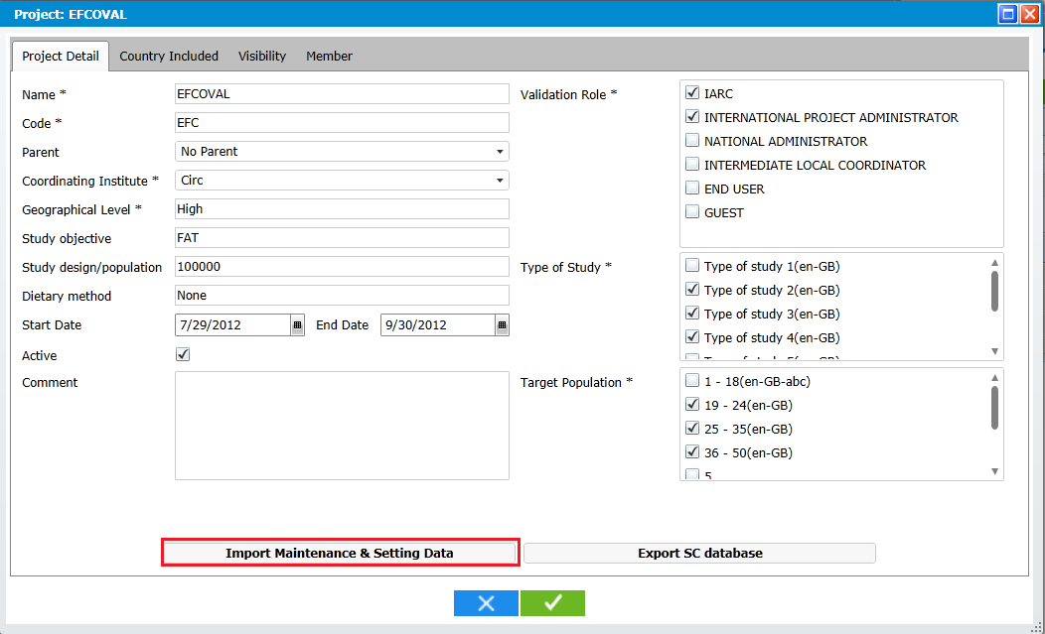
- Import From Parent Project
After click on the Total Import Button, a popup dialog will be displayed to allow user select the data to be imported:
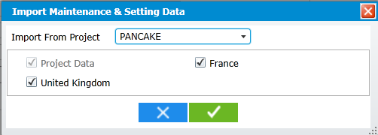
- Select data to be Import
In this dialog:
- If User selects a country --> Project Data is selected automatically.
- If User un-selects the Project Data --> All is un-selected
- The Total import can only be done once which requires to clear all existing data
Gwh:
- either it can only be done once _or_ it clears all the data. If it’s the second then there’s no reason to allow only one use.
- We should be able to import a country without importing the project data (with the condition that project data are already available)

[dtta]: We cannot do like this because it might cause a lot of incoherences in data from 2nd import. This's very complicate solution that we cannot have effort to do.

Click on OK button, a warning displayed: "This import action will require to clear all existing data, do you want to continue?". Yes / No

If user clicks on Yes --> All data in selected Perimeter will be imported to new projects with
- All Data
- Translation: of the languages which are common between 2 perimeters. (For example: PANKAGE / FRANCE has: English, French & German. EFCOVAL has: English, French, Spanish --> the English & French will be copy)

CC: In reality, we have different situations. The “Parent” project can be a national one (with only 1 country) or an international one with several countries attached.
In the first case, the total import will copy all the project and country-specific data.
In the second case, the user car copy the project data and the country-specif data attached to one country only (the most advanced in the fieldwork). This country will work on project data and country one. Then, when a second country is ready, the total import will have to copy the country-specific data and no more the project one (that are ongoing management).
In conclusion, the total import has to propose the copy of:
- project data (y/n)
- country 1 (y/n)
- country 2 (y/n)
- etc…
The project cannot be automatically copied when a country is selected. Can you review the pop-up design according to these cases?
This functionality can be available in the “feux verts” screen (or with the project screen?).

[dtta]: See my previous comment
- Table Import
In each screen, there'll have a button in action bar for "Table Import":
Gwh: this action should also be possible in the “Feux verts” screen. CC: The table import can only be done by a coordinator with hight level, so in most of the case, done in this “feux verts” screen. After this import, he/she will open the screen to users.

[dtta]: What's is "Feux verts" screen, is this new definition?

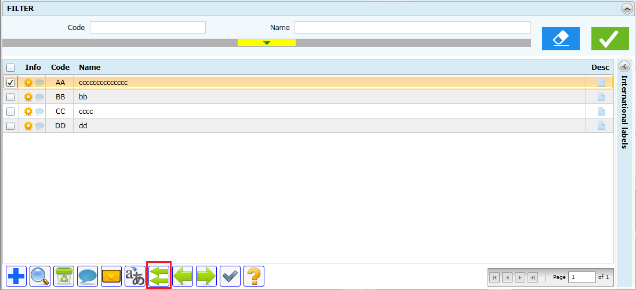
- Action Bar with "Table Import" button.
Click on Table Import button, a popup will be displayed:
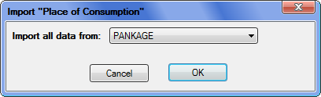
- Select Perimeter to import from
The Perimeter list contains all perimeters that the current perimeter has visibility as the same level.
Special case: For photo (HHM, Shape, Thickness, Series): Country can import from Library --> this special point has been defined in each checklist if has.

CC: I don’t undertand this remark? The table import is always from a same table from another project or another project/country. How do you plan for some project tables where data come from the library? For example for the food classification, if the project table is empty, then the library data has to be copied automatically or using the table import?

[dtta]: As discuss with Gwh before, for almost cases (food classification for example), after importing to project data, the country can use them. For the photo, if photos are imported to PANKAGE but not to PANKAGE-FRANCE, we cannot use this for PANKAGE – FRANCE.

Click on OK --> a warning will be displayed: "This action requires to clear all existing data.Do you want to continue? ". Yes / No.
Click Yes to do the import.
The following table shows the references between data (the clear of table in the left will require to clear all table in the right):
Table | Referent Table (to be cleared)
Days | No Import
Months | No Import
Food Consumption Occasion | N/A:  CC: importing the FCO table, can also clean the checklist table but not by deleting all the records (only records attached to fco no nore available).  [dtta]: The Table import requires to clear all data in this table first --> so all checklist has to be clear.  Checklist FCO
Checklist FCO | N/A
Place of Consumption | N/A
Spec. Days | N/A
Spec. Diets | N/A
Probing | N/A
Anthropometry | N/A
Nutrients | N/A
Nutrilimit | No Import
Improbable sequence of descriptors | No Import
Recipe pathway | No Import
ES Parameters | N/A
Note Status | N/A
Interviewers | N/A
Substit table (Food) | N/A
Food Classification | No Table Import, because all classification will be copied from Library automatically
Food Facets/Descriptors | All Countries Data  CC: no this case is not possible! The message is “you cannot import this table because country data are already available. Please use the “unitary import”.
Food FadebyGroup | All Countries Data  CC: no this case is not possible! The message is “you cannot import this table because country data are already available. Please use the “unitary import”.  [dtta]: OK
EPICTEXT | No Import
Food Facet rules | All Countries Data  CC: not impact on country data. This table depends on fadebygroup and facets/descriptors and classification. Not the opposite.  [dtta]: OK
Food Quantification by gr/subgr. | CC: no this case is not possible! The message is “you cannot import this table because country data are already available. Please use the “unitary import”.
Food Brand Name | N/A
HHM
Photo Series | Quantification by Food  Quantification by gr/subgr.
Shape | Quantification by Food  Quantification by gr/subgr.
Thickness
Food List | All FoodLinks
Foods: probing | With total Import Only
Facet by Food | With total Import Only
Quantification by Food | With total Import Only
Raw to Cooked | Table Import with Food List  CC: can also be imported alone not always with the food list.  [dtta]: this is Unit import (defined in checklist)
Standard Unit | Table Import with Food List  CC: can also be imported alone not always with the food list.  [dtta]: this is Unit import (defined in checklist)
Standard Portion | Table Import with Food List  CC: can also be imported alone not always with the food list.  [dtta]: this is Unit import (defined in checklist)
Density | Table Import with Food List  CC: can also be imported alone not always with the food list.  [dtta]: this is Unit import (defined in checklist)
Edible | Table Import with Food List  CC: can also be imported alone not always with the food list.  [dtta]: this is Unit import (defined in checklist)
Maximum | Import with Food List  CC: can also be imported alone not always with the food list.  [dtta]: this is Unit import (defined in checklist)
Nutritional Value | Import with Food List  CC: can also be imported alone not always with the food list.  [dtta]: this is Unit import (defined in checklist)
Fat during cooking | Import with Food List  CC: can also be imported alone not always with the food list.  [dtta]: this is Unit import (defined in checklist)
Fats/sauces/sweeteners adding | Import with Food List  CC: can also be imported alone not always with the food list.  [dtta]: this is Unit import (defined in checklist)
Fats/sauces left over in the dish | Import with Food List  CC: can also be imported alone not always with the food list.  [dtta]: this is Unit import (defined in checklist)
FUF | Import with Food List  CC: ?? not import?? I don’t understand  [dtta]: No Import because FUF is all above links
To be defined for Recipe & Supplement
CC: Please can you review this table according to Annex 4 in the SFG document (point 10) where the list of tables with import is specified?
[dtta]: Checked and updated
- Unit Import
- Common Case
On the list screen, click on Unit Import button:
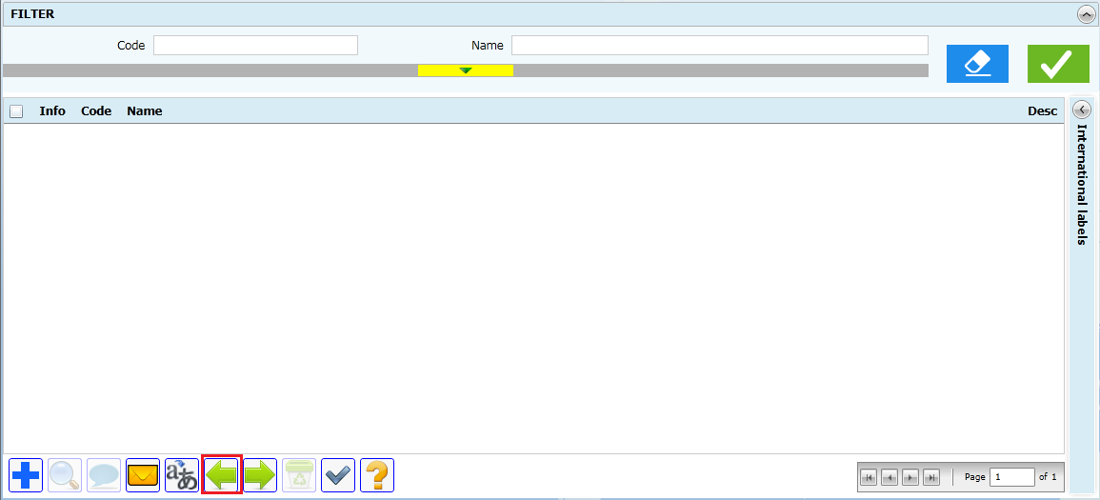
- Unit Import Button in red border
A popup dialog will be displayed; the content of this dialog is the same with list screen. User can select the perimeter to import from the search and select data to be imported.
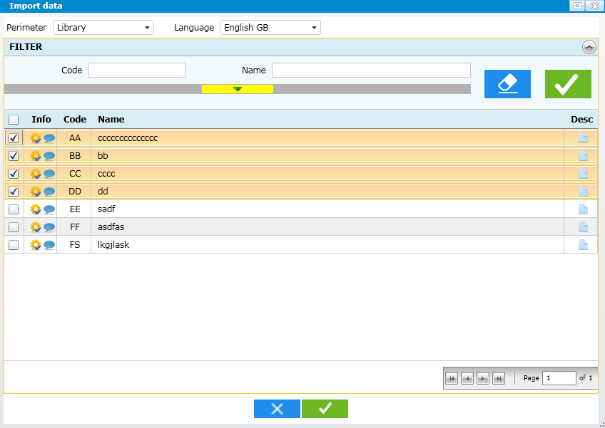
- Import Data
Click on OK button, all selected records will be imported to current perimeter:
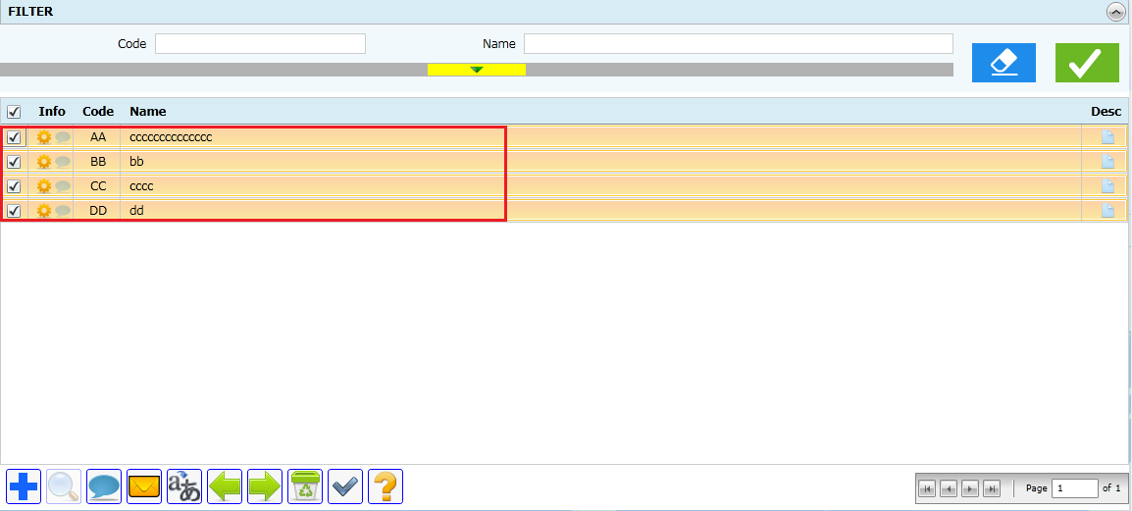
- Imported Data
CC: In this example, it is a unitary import for setting data, where screen is simple. How does it work with the food list for example? It can be interesting to specify it because the copied items are not only the food but all thea attached data (std units, coefficients…).
[dtta]: see updated below
- Unit Import for Food Links / Recipe Links
This type of import is applied for:
- Raw to Cooked
- Standard Unit
- Standard Portion
- Density
- Edible
- Maximum
- Nutritional Value
- Fat during cooking
- Fats/sauces/sweeteners adding
- Fats/sauces left over in the dish

This example will show the Unit import for Food Maximun:
In the Food Maximun, select a food in grid --> the Unit import button will be enabled:
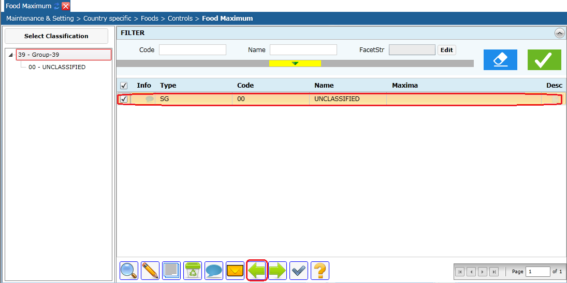
- Unit Import for Food Maximum
The popup dialog will be displayed:
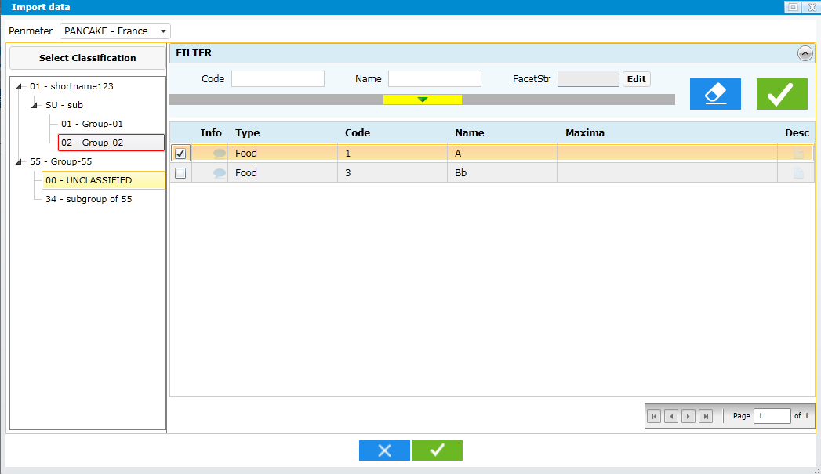
- Select maximun to import for selected food
In this dialog, user can select (single) a maximun to import to the selected food in list screen.
Click OK, the selected maximun in popup dialog will be copied to selected food of list screen.
- Unit Import for FoodList / Recipe List
In Unit Import screen, click Import button:
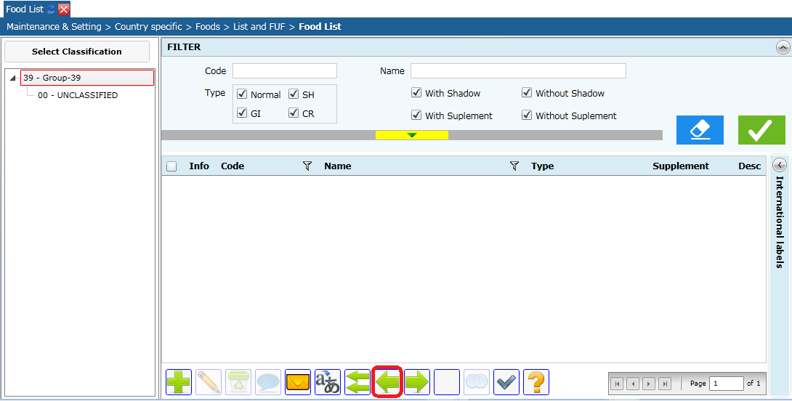
- Unit Import for food list
Popup display for selecting food(s):

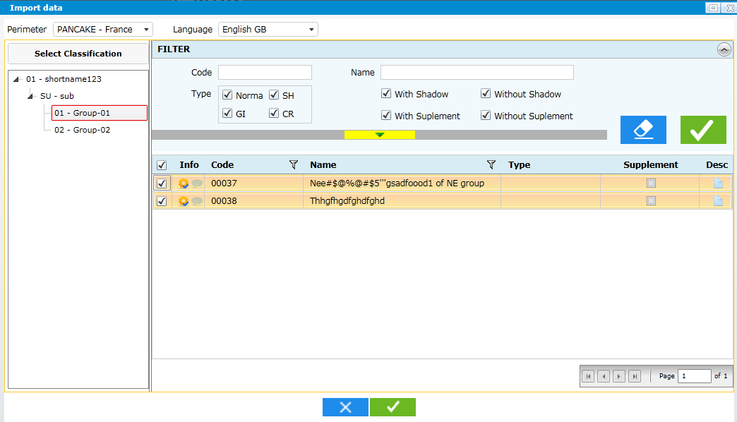
- Select Food to Import
Display a summary screen:
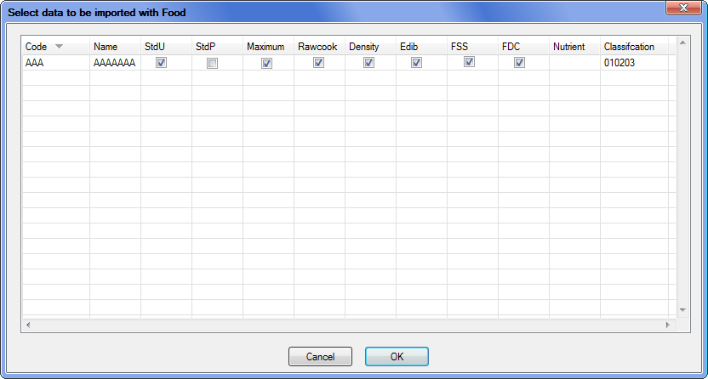
- Import FoodList – Summary
In this dialog:
- Choose which data to be imported with the selected food
- Double click on each row to change classification
- There'll have no checkbox for data which isn't available

Click on OK --> the selected data will be import to current perimeter
- CSV Import
Integrated in the design of each screen if has (checklist)
Gwh: need to detail the process. Could be similar to the upload interviews process for example (upload file, check, import). The user has to click on one button to do these 3 actions. A log file is generated specifying the accured problems/warning/well import.

CC: can you specify here the already asked csv-import already mentioned in the checklists.
The csv import will be available in:
- Food list
- Recipe list
- Supplement List
- Food BrandName
- Example of csv import
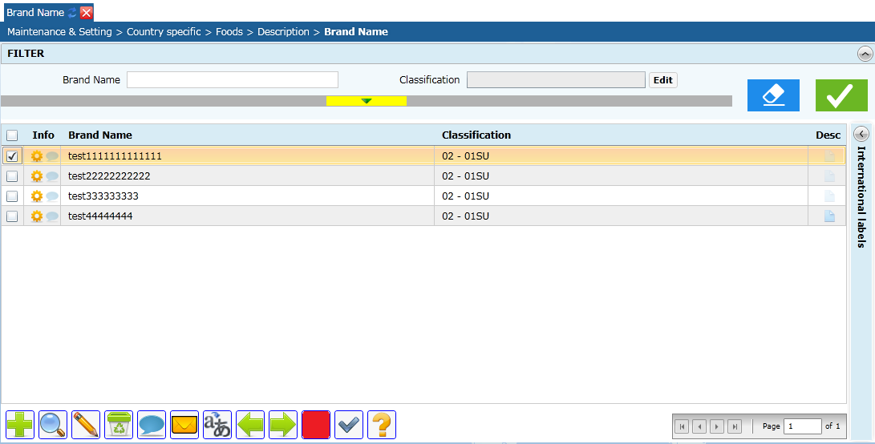
- Import csv
Click on import csv button (red), popup displayed to select csv file:
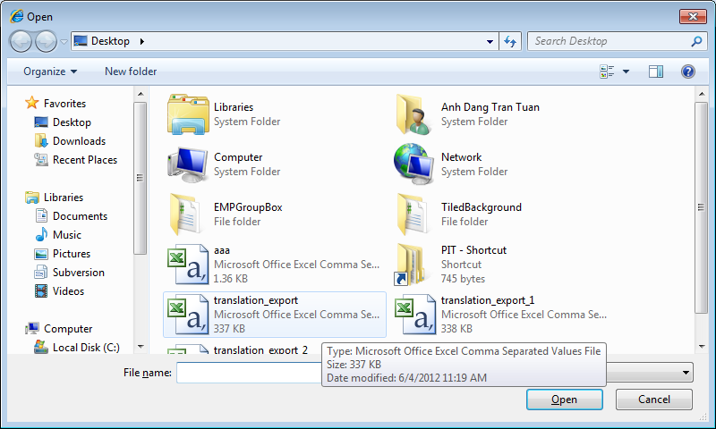
- Select csv file to be import
Select 1 file and click on open, ESMP will do the import for the selected file.
- If the format if not correct --> ESMP will display error message
- After the importation --> ESMP will display a log:
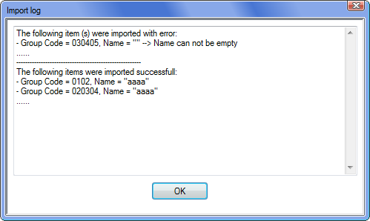
- Log of csv Import
- FoodList
Format of csv: FoodNum, Name, Type, Supplement, Order, Group Code

The FoodNum is used to map between a food & its shadow only--> this will not be used as "FoodNum" in the application.
Shadow of a food has the same food num with food and Type = SH
- BrandName
Format of csv: ClassificationCode, Name

Note: Classification code = Group Code + Subgroup Code (if has) + SubsubGroup Code (if has). For example:
- 01
- 0102
- 010203
- Export
CC: This part correspond to a screen/appraoch so it will be more logical to not have it here in general concept/design but in a special word document as a checklist. What do you think?

[dtta]: See my comment in part (4)
The Export Epicsoft Database is available only in Country. In MS Menu / Tools, Click on "Export Epicsoft Database" to open the versions management screen:
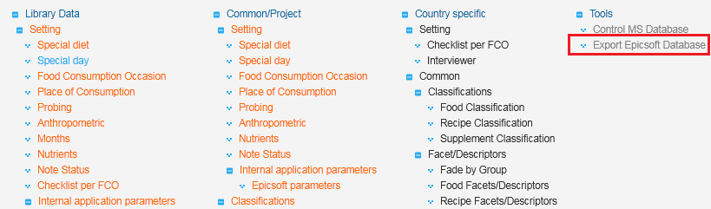
- Export Epicsoft Database
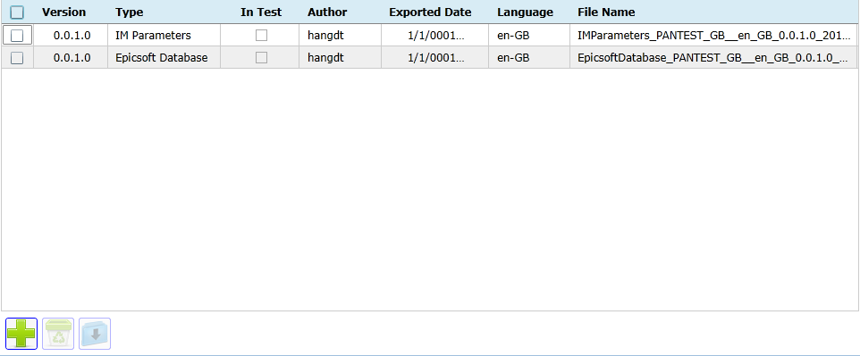
- Version Management Screen
In this screen user can see all exported versions in this perimeter:
- Create Epicsoft DB (): Create new version of Epicsoft database (xml)
- Delete (): Delete a version
- Download (): Download all selected version (s) in zip Gwh: need selection checkboxes for this
- Type: Epicsoft Database, IM Database or IM Parameters Gwh: what’s the difference between IM Database and IM Parameters?

CC: this part is not clear at all!
1. For the installation of IMapp in another server we will have to export:
- esmp-im database without interviews but some parameter data
- esmp-sc database with limited contain (only the data attached to the appropriate project)
- esmp-ms database with limited contain (only the data attached to the appropriate project)
Why do we have to go in MSapp to export esmp-im and -sc databases?
2. Create Epicsoft DB:
- This export will generate a xml-file and then the user will have to click on download buton to copy it on its own PC. Isn’t it?
- As described in the SFG point 9.2.10:
  - The export can be done on validated data only. So the controls have to be run first and if an error message is generated, then the export cannot be done.
  - If the export is possible, the user has to specify if it is a Epicsoft db export for the recipe manager application of for a check/pilot phase. If yes then all the values of State variable are not changed else, they are moved to “In use”.
  - Once the export done, the dietitians have to be informed and can connect to the platform to download the generated Epicsoft xlm-file and to import it in they PC sql database using the EPIC-Soft application.
- In this proposed screen:
  - We do not see the control run.
  - You propose to list all the Epicsoft xml-files available. I am not sure that it is what we need. Effectively, when the user exports the Epicsoft database, the previous export is automatically absolete and cannot be used anymore. Also for the dietitians that will download the database, we have to be sure that they use the last up-to-date one. We don’t want to stored all the xml-files available for all the projects/countries in our serveur; to much space). We can store a historic of the generation but not the xml-files.

[dtta]: Please see the 5.1, 5.2 and 5.3
Each user can do 1 or all these actions based on their function & role.
- Create Epicsoft Database
The Exporting of Epicsoft Database will need times (up to 15 mins). If MS data is changed during this period, database might be incoherent. So during the exporting Epicsoft Database --> The Modification of Data is locked for the exported perimeter:
The exporting will be done as following:
- Step 1: Do the control on all database (see part 4)
- If all the controls are good --> do the exportation.

At the beginning of the exportation, a confirmation might be needed. OK: an message can be displayed explaining the locked data.
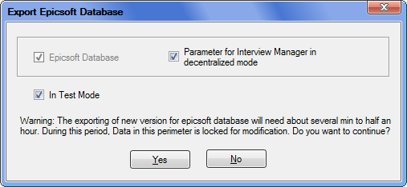
In this dialog, you can choose to export parameter for IM or not (default = not checked).

CC: For me this export is completely dependent of Epicsoft export. That can be 2 different buttons.

[dtta]: They must be exported at once to ensure the coherent (right after control)

Version Number: x.x.x.y: Where x.x.x is official version of epicsoft database, y is test version. For example:
- Official version: 0.0.1.0, 0.0.2.0, 0.1.1.0....
- Test version: 0.0.0.1, 0.0.0.2.....

Parameter for IM includes:
- Identification of setting: Project – Version – Country – Used Language and an Identification of the interview version.
- Translation for some of MS Data to exported language:
- Special Diet
- Special Day
- POC
- NoteStatuts
- FCO
- Quantification Method
CC: In reality, we will need a maximum of tables of MSapp because the future Recompute program available in IMapp will use a maximum of Epicsoft database.

[dtta]: We shouldn't do this because the export of all will be very heavy --> It'll be better if we customize the export for recompute later after we clearly know which is needed.

During the export, the log of the process will be displayed (Close button is disabled):
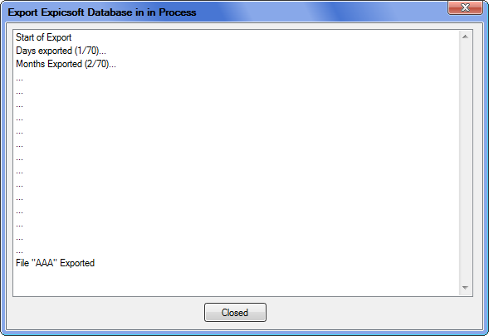
- Epicsoft Database - Export Process
Note: To be consistent with the Epicsoft Database (xml) Exported by Epicsoft Application, MS should use the same xsd that currently used by Epicsoft Application
Gwh: there is no such xsd defined at the moment. The format of the XML will need to be defined by Iteal.

[dtta]: The format is well defined in "EPICSOFT_DB_Sep10.xls", so it'll be the reference because no xsd.
- Export IM Database for Decentralized Mode
In Project Screen:
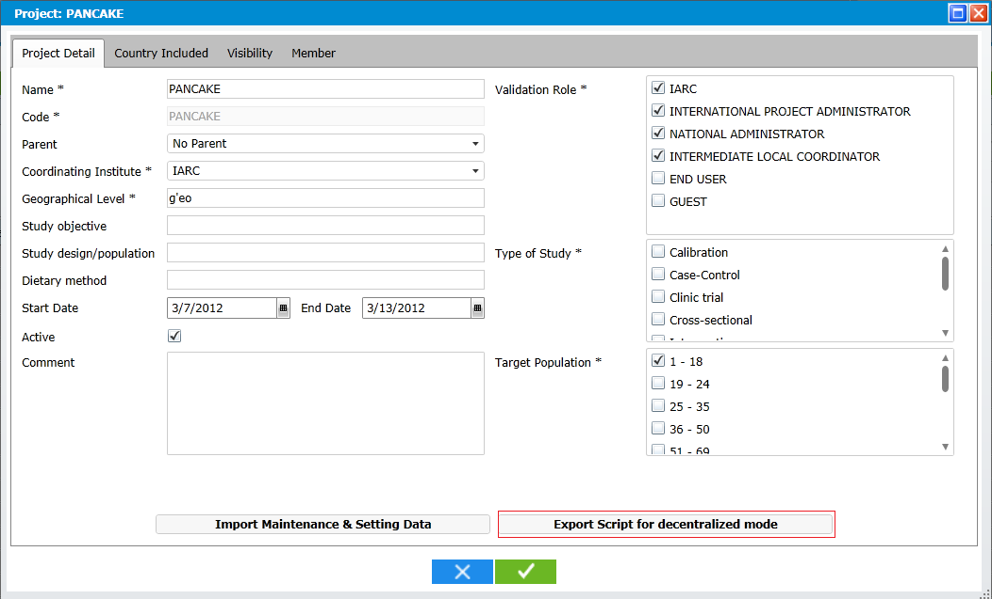
- Export SC database

Click on Export SC database to export the SC database for decentralized mode as "Sql script".

The following data will be needed:
- User Role & Permissions: Users / Functions / Projects. and all their related data (For this perimeter only)
- Interview Manager Database (in languages of this country) CC : is it esmp-im database or ??

Note: Some Translation aren't available in MS, so it's in english (data in MS_L_Fonctionnal_Param)
Gwh: these cases need to be listed and a way to translate them provided.
CC: True

[dtta]:
- OK for the feature implemented in SQLI version
- Evolution for the feature which isn't in SQL version.

During the exportation, the process will be displayed:
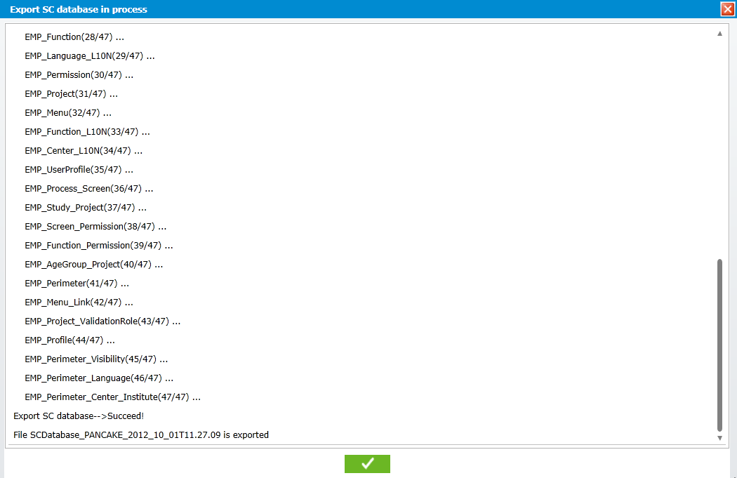
- Display process of Export SC database
To Configuration for Decentralized mode, the administrators will need
- Current SC database
- Current IM database
- SC data (Script)
- IM Parameter
They will have to do in the following step:
- (1): Build decentralized databases from current databases + SC scripts
- (2): Import IM Parameter (export by MS)
- (3): Deploy the e-SMP with <add key="DecentralizedMode" value="True"/> in Web.config
- Import IM Parameter
- In Centralized Mode: No need to import --> data is synchonized automatically at each export.

CC: not sure that it is the correct way to do? We need to do a export to have the IMapp data updated… and not in real time?

[dtta]: Do you mean to import manually even if in Centralized Mode?
- In Decentralied Mode: In Interviews Manager Menu, click on "Import Parameters" to import the xml exported from 5.1
- Online Help
The Online help is available on the platform EMP; it provides users the “guide line” for:
- The business processes supported by EMP
- The usage of the functions, screens of EMP
There’re 3 levels of Help:
- General: The Processes and data of library CIRC, the responsibility of the Principal Administrator.
- Project Level: the processes and common data of 1 project and the responsibility of project administrator.
- Country Level: the processes and data of 1 country, the responsibility of national administrator.
The EMP must implement the mechanisms for managing and viewing the help; the content of help will be made and uploaded by CIRC.
- Structure the help
Help files will be stored physically in the server as following:
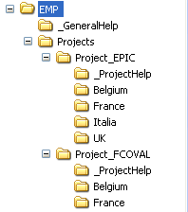
- Help files at International Level

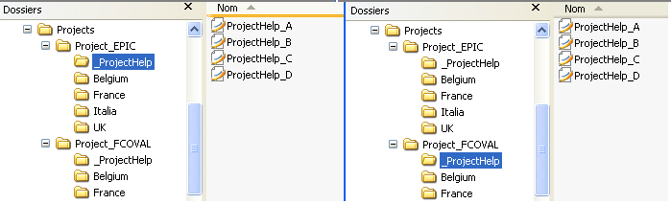
- Help Files at Project Level

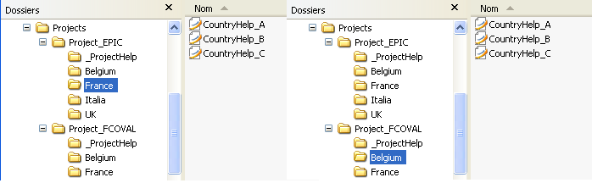
- Help files at Country Level

In the figure, the “EMP” is the root folder which used to store the help files:
- General Help (common help for all projects and help for the library CIRC) will be stored in the folder _GeneralHelp of root folder.
- Each project will have 1 corresponding folder named as project’s name in the «Projects » folder. Each country will have 1 corresponding folder named as country’s name in the corresponding project’s folder.
- The help for 1 project will be all in the folder _ProjectHelp in the project folder Gwh: why not put it directly in the Project_* folder as done for general help?
[dtta]: The Project Folder might have multiple file, it might causes you the difficulties when open this folder.
- The help for 1 country will be all in the country folder.
There’ll have 1 more help file in each help folder (sub folder).
- Administration
There is always 1 unique version for help; the uploading of a newer version will replace the previous version of help file.

In 1 screen, when user click on the help button, the EMP will detect its location includes:
- International Level or
- Project Level or
- Country Level
Based on this information, the EMP can find the correction help folder (based on structure) and all the help files on this folder will be available for user to select.
With this solution:
- The help (can be 1 or more help files) will be the same for all screens, functions that belong to 1 country, we can not separate help by screens, functions.
- The administration of help is simple, the administrator need only to organize all help files in the correct structure as described above.
- Accessing the help
The help will be accessible from the platform EMP with 1 help button on the action bar of each screen:
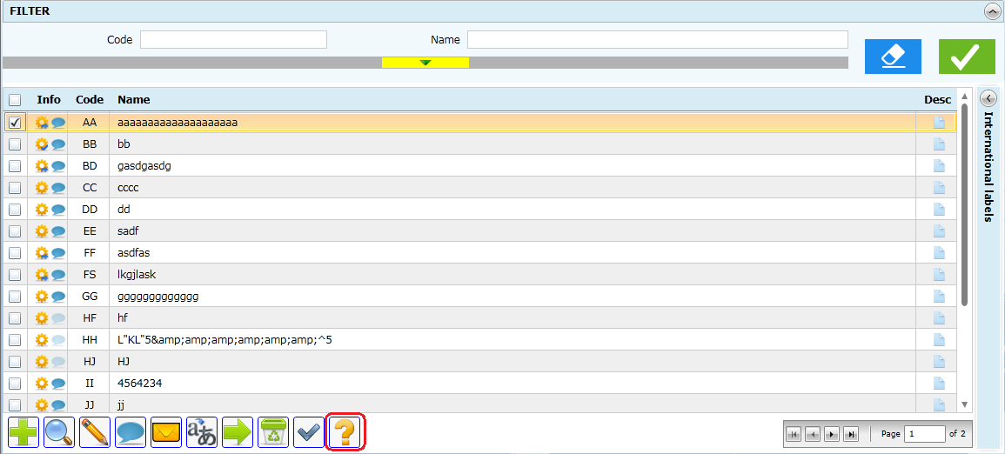
- Help button on action bar
Gwh: why not use the ‘?’ button in the header? If the help is access through the action bar as described here what is the header button used for?

[dtta]: It's clearer to understand that the help will be displayed in the context of "Selected Perimeter".

When user clicks on the help button, the EMP will find the associated help files that correspond with the current perimeter of user (Library, Project, and Country) and display to the user:
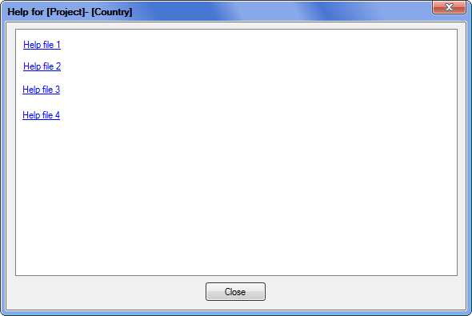
- Dialog to display all help files
For each file, user can (browser's actions, not by e-SMP)
- Open the help file in browser.
- Save the help file to user’s PC.

The help folder is a special folder on server, CIRC have to copy the help file into this folder following the above structure.

- Annex

